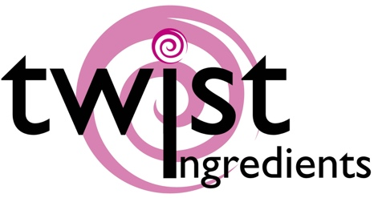
Truly (UK) Ltd  Sprinkles HQ  Brimfield  Ludlow  SY8 4NX | Product specification nutritional Information | May 2019  V1 2019

1755: Sprinkletti - Fiesta

Ingredients
Sugar, Potato Starch, Sunflower Oil, Rice Flour, Colours (E100, E102, E104, E110, E120, E122, E124, E129, E131, E132, E151, E163, E171), Milk Chocolate (53%) [sugar, cocoa butter (20% min), whole MILK powder, cocoa mass, emulsifier: SOYA lecithin, natural vanilla flavouring, cocoa solids: 32% min], Stabilizer (arabic gum), Rice Starch, Glazing Agents (carnauba wax, beeswax, shellac, acacia gum), Spirulina Extract, Apple Extract, Lemon Extract, Rapeseed Oil (partly hydrogenated), Thickener (tragacanth), Concentrate Of Sweet Potato, Radish, Apple, Cherry, Maize Starch, Un Hydrogenated Vegetable Fat (palm), Water, Emulsifier (rapeseed lecithin)
Allergens shown in CAPITALS

Nutrition facts | per 100 g
Energy value | 1812.33 kJ
Energy value | 428.40 Kcal
Total fat | 7.29g
. of which saturated fat | 3.71g
Carbohydrate | 89.50g
. of which sugars | 85.40g
Proteins | 0.88g
Salt | 0.21g

Storage conditions - 15° C – 25° C, dry

Allergens:
Milk, Soya
We handle the following allergens on site:- Wheat, Soya, Milk, Eggs, Fish
We are not a certified ‘Free From’ site – For further information please ask
We certify that all of our products do not contain any ingredients or raw materials manufactured from GMO substances.

Vegetarian | No
Vegan | No

This product information has been edited and checked carefully and corresponds to the relevant EC food legislation at this moment

