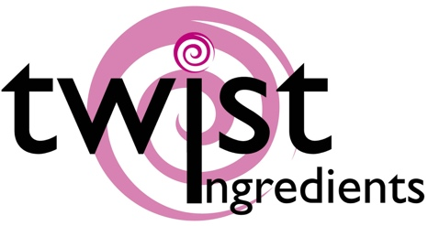
Truly (UK) Ltd  Sprinkles HQ  Brimfield  Ludlow  SY8 4NX | Product specification nutritional Information | May 2019  V1 2019

1745: Sprinkletti – Unicorn Poop

Ingredients
Milk chocolate [sugar, cocoa butter (20% min), whole MILK powder, cocoa mass, emulsifier: SOYA lecithin, natural vanilla flavouring, cocoa solids: 32% min], sugar, stabilizer: arabic gum, rice starch, natural vanilla flavouring, colorings (E120, E133, E171, E174), Gelatine (FISH), glazing agent: beeswax, carnauba wax, stabilizers: E460(i) & E464, emulsifier: E472α

Allergens shown in CAPITALS

Nutrition facts | per 100 g
Energy value | 2035.50 kJ
Energy value | 485 Kcal
Total fat | 19.15g
. of which saturated fat | 11.70g
Carbohydrate | 73.80g
. of which sugars | 72.60g
Proteins | 3.45g
Salt | 1g

Storage conditions - 15° C – 25° C, dry

Allergens:
Milk, Soya, Fish
We handle the following allergens on site:- Wheat, Soya, Milk, Eggs, Fish
We are not a certified ‘Free From’ site – For further information please ask
We certify that all of our products do not contain any ingredients or raw materials manufactured from GMO substances.

Vegetarian | No
Vegan | No

This product information has been edited and checked carefully and corresponds to the relevant EC food legislation at this moment

