SIGN UP IN 3 EASY STEPS
We are delighted to welcome you as a NeedToLive Partner. Getting your offers advertised on our online store is quick and easy, and after completing the details on this brief form, you’ll be live in a matter of days! We’re looking forward to adding valuable new customers to your business.
Please note: This form should be filled out in CAPITALS. Fields marked with a (*) are required.

STEP 1 – Contact Information

Type name here
Full Name*:
Type e-mail here
E-mail*:
Type contact number here
Contact Number:
Type business name here
Business Name*:
Type business address here
Business Address*:

STEP 2 – Product Details

Please fill out the table below with the number of products/services you’d like to offer. NTL Buy Price is the price we will buy your product from you, this is discounted. NTL Sell Price is the price we can sell your product for. Product Image is the image you want to advertise your product with.

Product Name | RRP | NTL Buy Price | NTL Sell Price | Product Image/s
Example Product | £10.00 | £06.00 | £08.00

STEP 3 – Additional Information

Type description here
Business Description:

Insert logo here or add it as an attachment when you send this form.
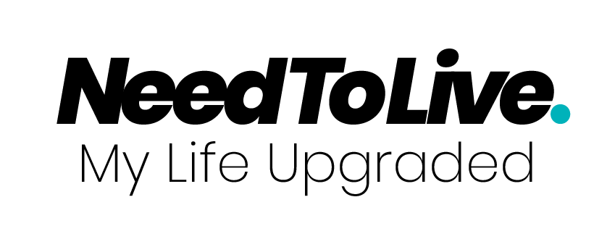
Business Logo:

Type any T&Cs with any of your products/services here
Terms & Conditions:
Online / In-Store / Via E-mail / Via Telephone
Redemption*:
How would you like customers to redeem your products or service. Delete which don’t apply.

Anything else:
If there’s anything else you would like us to know/advertise, please write it here.

Please send your completed form to admin@theneedtolive.com
Thank You!
3 Main FAQs

- How do I get paid?
We want to pay businesses as quickly as possible. Ever 7 days we will transfer money into your account via BACs or Paypal.

- How does NeedToLive make money?
We make commission on each sale, so it’s all about volume.

- Why is NeedToLive better than any other website?
We are the only website which gives businesses the choice of what discount/product/service they offer. We also create bundles like a first year university package where your products/services could be bundled together with multinational brands.

